WRONG correct screen

WRONG

CORRECT SCREEN

This screen should show till 4th Survey done

WRONG SCREEN

Upon clicking MYR 80 this is wrong screen THIS IS CORRECT SCREEN. This is a pop up.

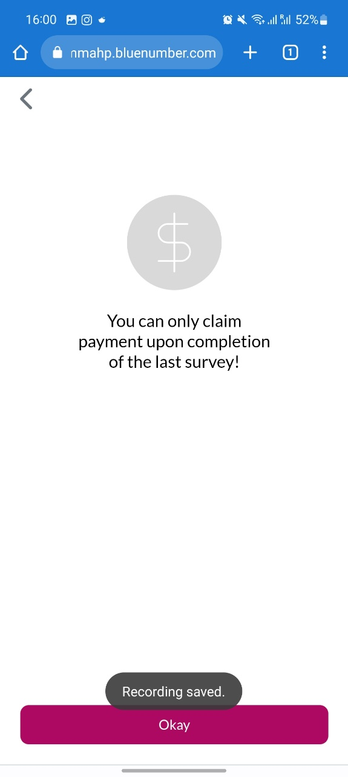

UPON 5Th survey completion

INSTEAD OF THIS SCREEN SHOULD DIRECTLY GO TO THIS SCREEN

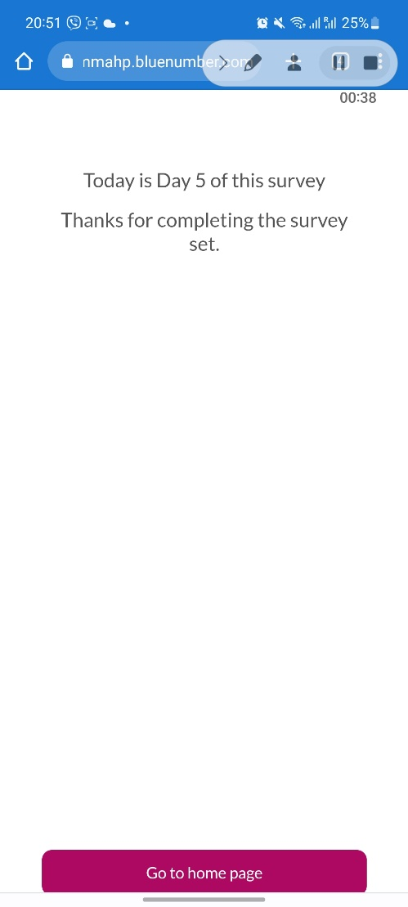

NOTE THE CHANGES IN THE QUESTION SCREENS FOR SURVEY SET  
  
NEXT instead of NEXT QUESTION

NO QUESTION NUMBERS. WE HAVE

PUT 17 CIRCLES IT WILL GET COLOURED AS THEY COMPLETE QUESTIONS.

NOTE CHANGES ON THE REQUEST SURVEY

NEXT Instead of NEXT QUESTION

5 circles for the REQUEST SURVEY  
  
It will also get coloured as they complete questions